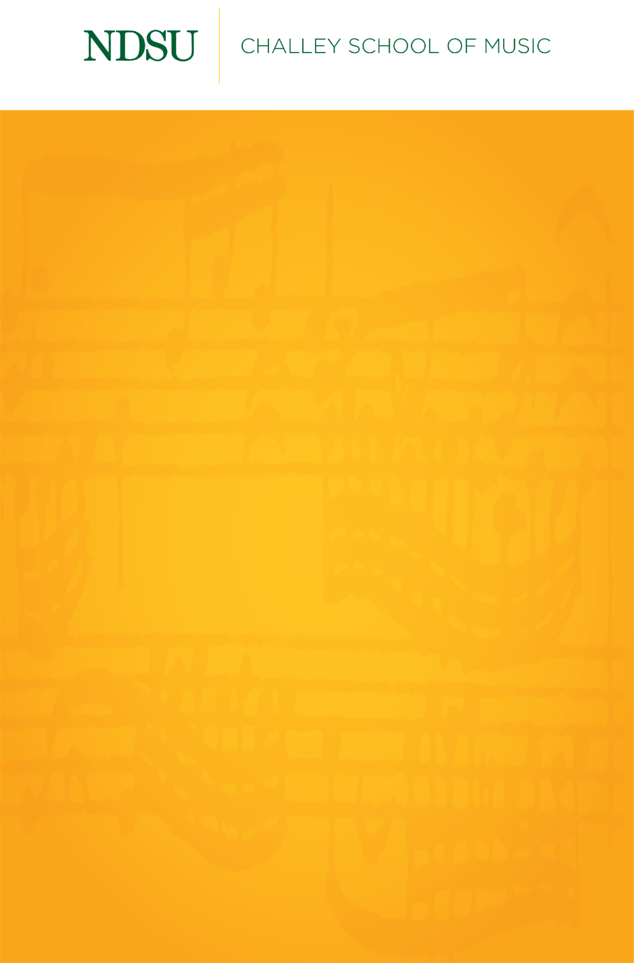

Name, Instrument

Name, Instrument

[Day of the week], [Month] [Day], [Year]

[Location]

[Time]

*Delete italic lines before submitting*

*For works with composer:*

Title Composer

(1000 – 2000)

Performer, Instrument

*For works with arranger:*

Title Composer (1000 – 2000)

arr. Arranger

Performer, Instrument

*For works with living composers:*

Title Composer (b. 1000)

Performer, Instrument

Intermission

Title Composer

(1000 – 2000)

Title Composer

(1000 – 2000)

Title Composer

(1000 – 2000)

**NDSU Division of Performing Arts**

**Upcoming Events**

Scan the QR code below or [click here](https://ndsuperformingarts.org/calendar/) to view upcoming events with NDSU Performing Arts. All events are subject to change. Always check the calendar for current information before attending any event. ***A qr code on a white background
***



**NDSU Performing Arts Box Office**

701.231.7969 | [ndsu.showare.com](https://ndsu.showare.com/)



